**Navigation setup / Container Setup**

Setup a Container to achieve the navigations between several menu options on the left hand side.

**References:**

<https://community.backbase.com/documentation/cxs/latest/build-a-navigation-widget>

<https://bitbucket.org/backbase/cxs-fe-uc-develop/src/master/container-template/>

**Steps:**

1. Create a container

Note: Container should be placed in prebuilt folder of collection-demo.

1. HBS file code (index.hbs)

{{#*inline "featureRoot"}}{{getConfig "contextRoot"}}/static/items{{/inline}}

<!DOCTYPE html>

<html>

<head>

    <title>{{preferences.title.value}}</title>

    <meta http-equiv="Content-Type" content="text/html; charset=UTF-8"/>

    <meta name="author" content="Backbase"/>

    <link rel="stylesheet" type="text/css" href="css/navigation.css"/>

    <script type="text/javascript">

        Handlebars.registerHelper('activeChild', function (text, url) {

            text = Handlebars.Utils.escapeExpression(text);

            url = Handlebars.Utils.escapeExpression(url);

            var result = '<a href="' + url + '">' + text + '</a>';

            return new Handlebars.SafeString(result);

        });

    </script>

</head>

{{#*inline "checkForOpenChild"}}{{#each datasource}}{{#isCurrent}}open active{{/isCurrent}}{{/each}}{{/inline}}

{{#*inline "renderListLabel"}}

    <div class="section__label {{#if children}} d-flex {{#if (equal withIcons 'true')}}justify-content-between {{/if}}{{else}}{{#if (and (equal withIcons 'false') (equal headerLevel '4'))}}{{#if preferences.menuIcon.value}}{{else}} title-indent--heavy{{/if}}{{/if}}{{/if}}">

        {{#if children}}

            {{#if (equal withIcons 'false')}}

                <a role="button" data-toggle="dropdown" data-hover="dropdown" class="dropdown-toggle pr-1 pl-2">

                    <i class="toggle-icon material-icons">keyboard_arrow_down</i>

                </a>

            {{/if}}

        {{/if}}

        <a class="{{#if children}}{{else}}w-100{{/if}}{{#if children and equal withIcons 'false'}} pl-1{{else}}{{/if}}"

         data-target="{{#if (or (equal type 'page') (equal type 'alias') (equal type 'externalLink')) }}{{getConfig

                 'linkRoot'}}/{{url}}{{else}}#{{/if}}"

         href="{{#if (or (equal type 'page') (equal type 'alias') (equal type 'externalLink')) }}{{getConfig

                 'linkRoot'}}/{{url}}{{else}}#{{/if}}">

            {{#if preferences.menuIcon.value}}

                <i class="icon material-icons" title="{{title}}">

                    {{preferences.menuIcon.value}}

                </i>

            {{else}}

                {{#if (equal withIcons 'true')}}

                    <i class="icon material-icons" title="{{title}}"></i>

                {{else}}

                {{/if}}

            {{/if}}

            <span class="nav-item-title">{{title}}</span>

        </a>

        {{#if children}}

            {{#if (equal withIcons 'true')}}

                <a role="button" data-toggle="dropdown" data-hover="dropdown" class="dropdown-toggle pr-2">

                    <i class="toggle-icon material-icons">keyboard_arrow_down</i>

                </a>

            {{/if}}

        {{/if}}

    </div>

{{/inline}}

{{#*inline "showLink"}}

    {{#each datasource}}

        {{#if (equal type 'menuHeader' )}}

                <li class="header pl-0 pr-0 headerLevel--{{headerLevel}}">

                    {{#if (equal headerLevel '4')}}

                        <span class="header__title col pt-2 pb-2 d-block">{{title}}</span>

                    {{/if}}

                    <ul>

                        {{#with children}}

                            {{> showLink datasource=this headerLevel = (divide headerLevel 2)}}

                        {{/with}}

                    </ul>

                </li>

        {{else if (equal type 'divider')}}

            <li class="divider"></li>

        {{else}}

            {{#if children}}

                <li class="section dropdown w-100 d-inline-block {{#isCurrent}}active{{/isCurrent}} {{#with

                        children}}{{> checkForOpenChild datasource=this}}{{/with}} {{#if (equal withIcons 'false')}}children-indent--heavy{{/if}}">

                    {{> renderListLabel datasource=this}}

                    <ul class="dropdown-menu multi-level" role="menu">

                        {{#with children}}

                            {{> showLink datasource=this headerLevel = (divide headerLevel 2)}}

                        {{/with}}

                    </ul>

                </li>

            {{else}}

                <li class="section {{#isCurrent}}active{{/isCurrent}}">

                    {{> renderListLabel datasource=this withIcons=withIcons}}

                </li>

            {{/if}}

        {{/if}}

    {{/each}}

{{/inline}}

<body class="bb-universal-nav navbar navbar-default">

<ul class="nav flex-column {{preferences.customNavClasses.value}}">

    {{#if preferences.fixedRoot.value}}

        {{> showLink datasource=datasources.nav-fixed withIcons=preferences.withIcons.value headerLevel=8}}

    {{else}}

        {{> showLink datasource=datasources.nav-ds withIcons=preferences.withIcons.value headerLevel=8}}

    {{/if}}

</ul>

</body>

</html>

1. After creating these files run following two commands for creating package and importing , in your project Root:

**bb-package --prebuilt=./**

**bb-import package package.zip --portal-port=8080 --portal-host=localhost --portal-version 6**

1. Changes in CXP manager:
2. Changes on master page:
3. Add Columns Container (CX 6) (Refer screenshot below)

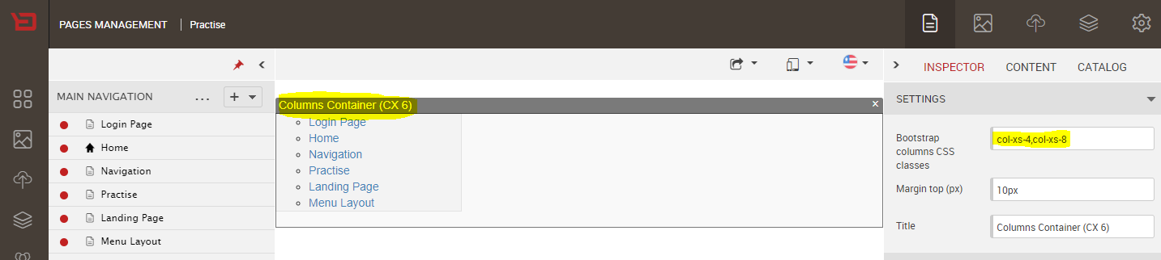

1. Drag and drop created navigation container.
2. Drag and drop Main Navigation link to “Fixed root” option (see screenshot below).

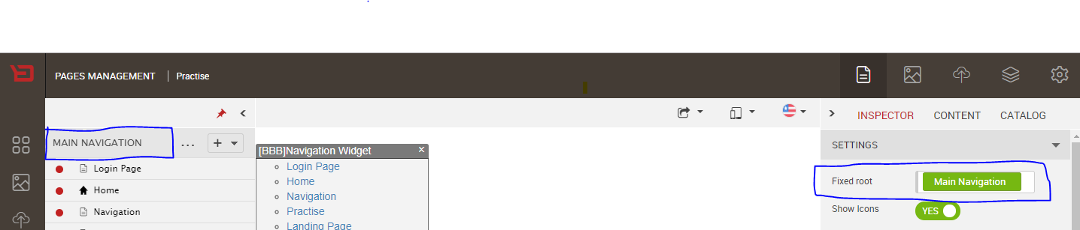

1. Changes on pages that are present on main navigation:
2. Add App container on page.
3. Drag and drop widget which you want show on that page.